2019 Qingdao International Water Conference

June 25-28, 2019 Qingdao, China

Global Platform For Water Solutions

Major Sessions

International Conference on Seawater Desalination
- Seminar on the Innovation and Development of Seawater Desalination Technology
- Seminar on Brine Resources Exploitation and Comprehensive Utilization
- Seminar on Treatment and Reuse Technology of Civil Sewage
- Seminar on Landfill Leachate Treatment Technology
- Seminar on Sludge Treatment and Resource Utilization Technology
- Seminar on Application Technology of Water Treatment Chemicals

Conference on National Industrial Water Conservation and Treatment Technology
- Seminar on Pollution Control and Resource Utilization Technology of Oil and Gas Field Development
- Seminar on Wastewater ZLD Technology in Coal-based Chemical Parks
- Seminar on Wastewater Reuse and ZLD in the Power Industry
- Seminar on Difficult Technology for Industrial Wastewater Treatment
- National Seminar on Water Conservation and Wastewater Comprehensive Utilization technology in Metallurgical Industry

Water Science and Technology
- Seminar on New Materials and New Progresses of Membrane Separation Technology
- Seminar on Anaerobic Technology
- Young Scientists Forum on Water Science
- Networking on China-Europe Water Resources Technology Innovation and Business

Water Environment Governance and Water Ecology Construction
- Seminar on Water Ecology and Culture Construction & Integrated Governance and Innovation of Water Bodies
- Seminar on Non-Conventional Water Resources Development and Utilization technology
- China Development Summit on Smart Water Affairs
- Seminar on Decentralized Wastewater Treatment Technology in Rural Areas and Small Towns

Awarding Ceremonies
- The 4th Awarding Ceremony for "Chinese Top Water-Making Craftsmen"
- The 3rd Awarding Ceremony for“China Water Industry Stars”
- The 2nd Awarding Ceremony for“China Water Industry Champions”
- Awarding Ceremony for Top Papers of Young Scholars

Field trip

Highlights

- The Qingdao International Water Conference is founded by the Chinese government and supported by industrial organizations around the world;
- The Conference gathers together over 2,300 leaders, experts and professionals in water treatment industry from more than 50 countries;
- More than 300 important guest speakers meet and discuss business opportunities and technology development strategies of the environmental protection industry in the backdrop of the global water resource crisis.
- The conference consists of five key-note themes and 30 special sessions, composed of 380 authoritative professional reports.
- This annual event has developed into the largest, highest level, most influential and professional exhibition brand of the water industry in Asian-Pacific region.

Organizational Structure

Hosted by
China Association for Science and Technology
Qingdao Municipal People's Government

Supported by
International Water Association
Shandong Association for Science and Technology

Organized by
Qingdao Association for Science and Technology
Administration Committee of Qingdao West Coast New Area
Qingdao International Desalination Center
Co-Organized by
Desalination Branch of the China Water Enterprises Confederation
The Chinese Society for Metals
China-Europe Exchange Platform for Water Resource
Water Conservation and Treatment Branch of the China Industrial Energy Conservation and Clean Production Association
National Engineering Research Center for Integrated Utilization of Salt Lake Resources
National Engineering Research Center for Petrochemical and Coal-Based Chemical Wastewater Treatment and Resource Reuse
Shandong Salt Industry Group Co., Ltd.
Shandong Environmental Protection Technology Service Center
Shandong Coating Industry Association
Jiangsu Industrial Association for Manufacturing Water Purification Equipment
EU-China Commercial Associations Investment Promotion Alliance

Background
The Qingdao International Water Conference (QIWC) is hosted by the China Association for Science and Technology and Qingdao Municipal People's Government, supported by industrial organizations and national government departments such as the International Water Association and Shandong Association for Science and Technology. QIWC is co-organized by the Qingdao Association for Science and Technology, Administration Committee of Qingdao West Coast New Area and Qingdao International Desalination Center. As a high-end international academic and technical convention and exhibition, it has been held for 13 consecutive years as an influential event at home and abroad, providing an interdisciplinary exchange platform in the areas of water-related resources, environment, ecology and security, for promoting the development of water treatment industries in China and the world. Meanwhile, the leaders from both the government and industries are invited for the releasing of the information on policy planning, project demands and development trends in this field.
The 14th Qingdao International Water Conference will be held in Qingdao, China on June 25-28, 2019. The diverse content and themes of QIWC provide a platform for global water resources solutions, drawing entrepreneurs, experts and professionals to address challenges, exhibit technology, explore opportunities and share achievements. As an influential and popular event in the industry, QIWC has grown into a renowned international brand of convention and exhibition in the Asia Pacific region. Every summer sees the gathering of the experts and business representatives in the global water industry in Qingdao, making friends and exchanging ideas in promotion of the water treatment technology and industry.

Participants
- National and local leaders in water-related resources, environment, conservation and treatment
- Experts, scholars, researchers and entrepreneurs in the global desalination field and related fields
- Members and representatives from the International Water Association, Desalination Branch of the China Water Enterprises Confederation, The Chinese Society for Metals, Shandong Water Ecology Civilization Promotion Association, European Desalination Society and other associations and organizations
- Engineers and technicians from domestic and foreign water treatment companies; representatives of water affairs companies, research institutes and news agencies, as well as users, investors and entrepreneurs, etc.

Key Participants in previous events

National Development and Reform Commission Ministry of Science and Technology
Ministry of Environmental Protection Ministry of Water Resources
State Oceanic Administration China Association of Science and Technology
The Institute of Seawater Desalination and Multipurpose Utilization, SOA (Tianjin)
Development Center of Water Treatment Technology, Hangzhou
Gansu Academy of Membrane Science and Technology Tsinghua University
Tianjin University Ocean University of China Tongji University
Dalian University of Technology Tianjin Polytechnic University Harbin Institute of Technology
Hohai University Nanjing University of Technology Zhejiang University
Xinxing Ductile Iron Pipes Co., Ltd. China Metallurgical Group Corporation
China Huadian Engineering Group Shanghai Electric (Group) Co., Ltd.
China First Heavy Industries Harbin Electric (Group) Co., Ltd.
China Electronics Engineering Design Institute Beijing Enterprises Water Group Limited
China Power Engineering Consulting Group China Hydropower Consulting Group
Beijing Municipal Design Institute Technical Research Institute of Shougang Group
China Institute of Water Resources and Hydropower research
Ningbo Materials Institute of the Chinese Academy of Sciences Northwest Electric Power Design Institute
SUEZ Dow Veolia Xylem
Doosan Toray Nitto Denko Saint-Gobain
Abengoa BASF ITT KSB AG
LG Koch IDE AsahiKASEI
Hyflux Pentair Pall PUB Singapore
Cadagua ACS COBRA Aqualyng Black&veatch
ACWA Toshiba Hitachi LANXESS
Fesia Sidem EBARA Outokumpu
ERI Biwater Sulzer Pump Engineering
Calder AG Industeel Naclo SembCorp Utilities
Inge A.G. Toyobo BWA Prominent
Wabag BRACK Genesys Woongjin Chemical
Azud Hach Butting Schlumberger Water
CH2M HILL Flowserve FCC Grundfos Pump
Kurita Danfoss Mitsubishi Sumitomo Corporation
Porex AkzoNobel ANDRLIZ Modern Water
GEMU AZUD ABB Litree
Harbin ROPV Iwowater RRS Originwater
Bray MOTIMO Vontron Wave Cyber
Canpure Scinor Cobetter Nanfang Punp
Haier TCL 3M A.O.Smith
Unilever Ozner Angelgroup Tritech
SOLAREAST

Theme
Water——Source of Life and Basis of Development

Content
Keynote speeches, comprehensive reports, special sessions, business networking, results transfer, product display, field trip

Topics
International Conference on Seawater Desalination
Seminar on Innovation and Development of Seawater Desalination Technology
- Current situation and progress of the desalination Industry
- Innovation of RO membrane seawater desalination technology
- Innovation of thermal seawater desalination technology
- Seawater desalination and environmental issues
- Technology on using, efficiency and energy recovery of seawater desalination energy
- Pre-treatment and post-treatment technology
- Anti-corrosion control and material selection
- Process design, operation management and economy of seawater desalination projects
- Application of products that support desalination
Seminar on Development and Integrated Utilization of Brine Resources
- Exhibition on reducing saline wastewater and efficient use of it as a resource
- New technologies and developments on utilizing brine
- Technical routes, engineering cases and economic analysis of water-salt co-production
- Comprehensive utilization and green development of salt lake resources
- Separation and extraction of valuable elements from brine resources (seawater, salt lakes, underground brine, etc.)
- High-value product development of bittern chemical resources
- Platform construction for testing and inspecting brine utilization
Seminar on Treatment and Reuse Technology of Civil Sewage
- Market development of civil sewage treatment
- Advanced treatment technology and process developments of civil sewage
- Application of membrane technology in civil water treatment
- Typical case analysis of civil sewage treatment and reuse
Seminar on Landfill Leachate Treatment Technology
- Interpretation of policies and standards on landfill leachate treatment and discharge
- Progress in landfill leachate treatment technology
- ZLD and economy of landfill leachate
- Typical Processes and Case Analysis of Landfill Leachate Treatment
Seminar on Sludge Treatment and Resource Utilization Technology
- Interpretation of policies and standards on urban sludge treatment industry development
- Technology progress and case sharing of sludge treatment and disposal projects
- Development and engineering application of new conditioning techniques for pyrohydrolysis anaerobic sludge
- Research and application process of utilizing sludge as a resource
Seminar on Application Technology of Water Treatment Chemicals
- Application of water treatment agents in the industrial field
- R&D and application of special agents for seawater desalination
- R&D and application of cooling water agents
- R&D and application of reverse osmosis agents

National Technology Exchange on Industrial Water Conservation and Pollution Control
Seminar on Pollution Control and Resource Utilization Technology of Oil and Gas Field Development
- Policies and regulations on environmental protection in the case of water intake and discharge in oil and gas industry
- Advances in pollution control and resource utilization technologies for oil and gas development
- New technology on wastewater treatment and reuse in oil and gas industry
- Integrated solutions and case analysis on wastewater treatment and water reuse in oil and gas production
Seminar on Wastewater ZLD Technology in Coal-chemical Zones
- Ideas on the development of the coal-based chemical industry in the new situation
- Progress of treatment technology for high pollution and high salinity wastewater
- Application of membrane separation technology in coal-based chemical wastewater ZLD
- Case studies of wastewater ZLD projects in coal-based chemical parks
Seminar on Wastewater Reuse and ZLD in Power Industry
- Energy conservation and emission reduction policies and regulations of the power industry
- Progress in wastewater efficient utilization and ZLD technology of power plants
- ZLD technology for desulfurization wastewater
- Application of integrated membrane technology in the boiler feed water treatment of power plants
- Application of seawater desalination technology in the power industry
- Optimization design and economic analysis of water treatment projects in power plants
Seminar on Highly-difficult Treatment Technology for industrial wastewater
- Turning industrial wastewater into a resource and industrial policy analysis
- Developments in industrial wastewater pretreatment process
- R&D and application of key technical equipment in the case of anaerobic oxidation and supercritical oxidation
- Low energy-consumption and high-efficiency advanced membrane treatment technology and application
- Application of evaporation crystallization technology and salt separation and hazard-free disposal technology
National Seminar on Water Conservation and Wastewater Comprehensive Utilization technology in Metallurgical Industry
- Current status and development trends of water resources utilization in the iron and steel industry
- Water conservation in iron and steel enterprises and urban wastewater treatment and renewable technology
- Reduction of coking wastewater and its advanced treatment technology
- Treatment and comprehensive utilization technology of industrial wastewater with acid, oil, extractant and heavy metal in the case of sintering, iron making, steel making and steel rolling
- Application of seawater desalination technology in the water treatment of the iron and steel industry
- Typical case studies of wastewater comprehensive utilization in the iron and steel industry

Water Science and Technology 
Seminar on New Materials and Developments of Membrane Separation Technology
- Research progress in mixed matrix membranes, renewable material membranes, biomimetic membranes, etc.
- Electrochemistry, pressure-driven membrane and membrane processes
- Research and development of ZLD and near-zero emissions and utilizing membranes as resources
- Research and practice of short-flow seawater desalination technology
Seminar on Anaerobic Technology
- Industrial and urban wastewater treatment depending on anaerobic technology
- Innovation / emerging anaerobic technology
- Anaerobic technology for resource recovery
- High solid anaerobic treatment technology
- Pretreatment and post treatment of anaerobic technology
Networking on Innovation and Business of China-Europe Waster Resources Technology
- Release of China-Europe new technologies in key areas of water treatment, watershed management, remediation of water ecology, and sponge city
- Release of China-Europe water technology demand
- Business networking of China- Europe enterprises

Governance of Water Environment and Construction of Water Ecology
Seminar on Construction of Water Ecology Civilization and Innovation on Water Bodies Comprehensive Treatment
- Construction and development planning of water ecological civilization
- Progress of implementing River Chiefs and River-Chief informatization construction
- Integrated thinking on constructing ecological water networks in connection with river and lake water systems
- Key technologies for watershed water environment governance and ecological remediation
- Key technologies for wetland ecological protection and restoration
- Technological innovation and application of dredging and sediment dredging in rivers and lakes
- Disposal and comprehensive utilization of sediment in rivers and lakes
- Development and innovation of water ecological PPP investment and financing mechanism
China Smart Water Development Summit
- Layout and planning of national smart cities
- Analysis on the development prospects and modes of investment and financing of smart water affairs
- Solutions on smart pipeline network for water supply
- Discussion on smart drainage solutions
- Sharing of cases and applications of smart water affairs
Seminar on New Technology for Decentralized Wastewater Treatment in Rural Areas and Small Towns
- Market development of sewage treatment in villages and towns
- sewage treatment technology and process developments in villages and towns
- Management and case studies on operation and maintenance of sewage treatment projects in villages and towns
- Discussion on commercial modes of sewage treatment in villages and towns

Call for Papers
1. 5,000 words required for a paper along with an abstract of 200-300 words. An English abstract of 1,000 words is required for a paper written in English
2. Format of Chinese Papers: (1) Title (18, SimSun); (2) Authors a, b, c (14, KaiTi ); (3) Organizations (10.5, SimSun, 10,Times New Roman ), (4) Chinese and English Abstracts (10.5., KaiTi); (5) Key words (10.5, KaiTi); (6) Text (5, SimSun, 16 spacing, 28.5cm×21.0cm); (7) References (5, SimSun).
英文论文经审核，可被Desalination and Water Treatment (SCI journal)期刊收录，格式参见：
Desalination and Water Treatment (SCI journal) http://www.deswater.com/instructions.php
Selected papers will be recommended for publication on the Desalination and Water Treatment (SCI journal). Following is the paper format and style respective: http://www.deswater.com/instructions.php
Deadline: March 31, 2019 for titles and abstracts; May 31, 2019 for full texts. Contributions are welcome. Please send your papers to yang_yan90@126.com or cdashy@163.com.

Date | Agenda
June 25, 2019 | Full-day Registration
June 26, 2019 | Opening Ceremony/ Plenary Keynotes/ Sessions/ Exhibition
June 27, 2019 | Sessions/ Exhibition/ Networking
June 28, 2019 | Field Trip

Display of Technology and Equipment

Exhibition involves:

►Technology, products and equipment of desalination and water treatment
►Supporting facilities and components for water treatment engineering and configuration
►Membrane and membrane modules, complete equipment
►Application technology and equipment for water conservation and using wastewater as a resource
►Engineering technology and supporting management
►Professional service providers in media, intelligence, consulting, software, etc.
►Equipment for sludge treatment

Size and price of booth
Rental of standard booth（6m²）
1. Foreign company: 2,000 US$ 1. Foreign company: 2,200 US$
2. Domestic company: 8,000 yuan 2. Domestic company: 9,000 yuan
A standard booth is equipped with: the higher than usual structure, one exhibition table, two chairs, a lintel bearing the company logo in both Chinese and English, two spotlights, 220V power socket, and booth carpet.

Registration
- Registration Fee
Delegates |  | Remittance in Advance | On-site payment
Domestic Delegates | Members | 2,800元yuan/person | 3,000 yuan/person
Domestic Delegates | Non-members | 2,900 yuan/person | 3,100 yuan/person
Foreign Delegates |  | 800 US$/person | 900 US$/person

The fee covers the admittance to the conference, meals, materials and field trip.
- Accommodation of the delegates will be subject to the organizing committee at their own expense.

Procedure
1. Please fill in the application form and send it to the organizing committee by email, WeChat, QQ, or fax before May 31, 2019.
2. Registration fees can be directly transferred to the organizing committee or paid on site.
3. After participants remit fees, please fax the remittance slip to the organizing committee for verification.

Sponsorship
The sponsorships are offered as follows:
Platinum sponsor, gold sponsor, silver sponsor, co-sponsor, banquet sponsor, gift sponsor, etc.
For those interested in the sponsorship, please contact the organizing committee directly for detailed information.

Remittance
Intermediary Bank: JPMorgan Chase Bank New York
SWIFT BIC: CHASUS33
Beneficiary Bank: Bank of Communications Qingdao Branch
SWIFT BIC: COMMCNSHQDO
Name of account: Qingdao International Desalination Centre
A/c No of account: 372005513018170040169

Contact Information

Qingdao International Desalination Centre
Qingdao Office Beijing Office
Contact: Gong Haichen, Guo Hongshun Contact: Yang Yan, Guo Wei
Tel: 86- 532-86679768 Tel: 86-10-58678266
Fax: 86-532-86679769 Fax: 86-10-58678266 to 8011
E-mail: cdaghc@163.com E-mail: yang_yan90@126.com
2631070062@qq.com 13718860917@126.com
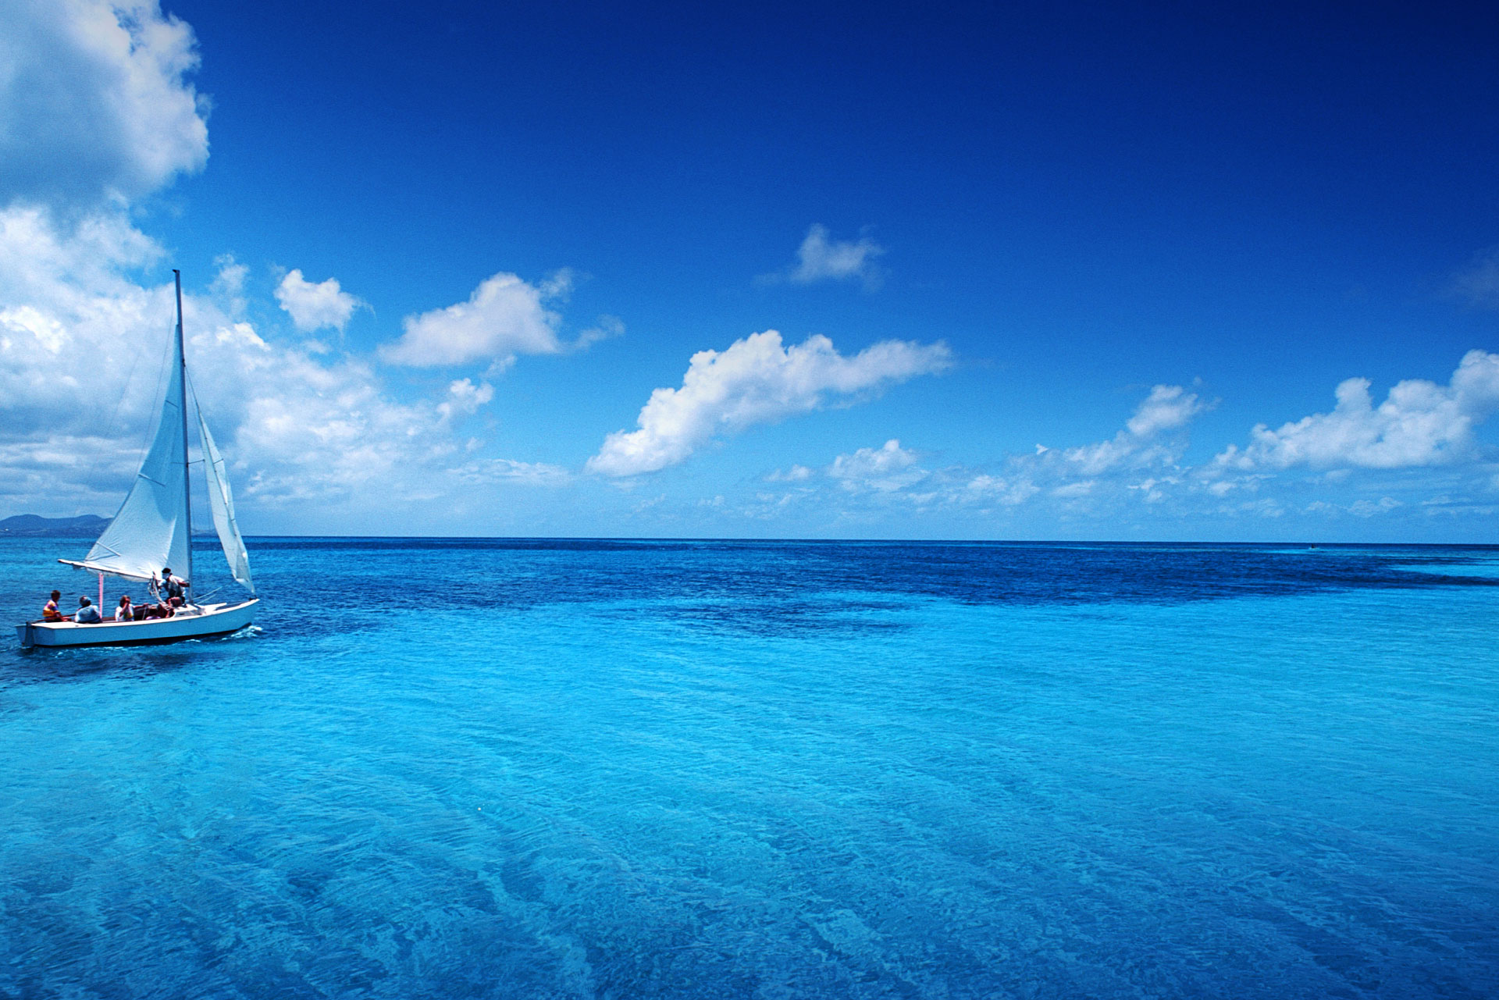
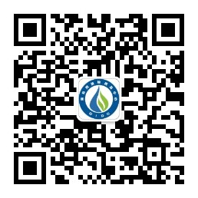
Scan the code,welcome to attention
Official website link:
http://www.cda-apdwr2009.com/

