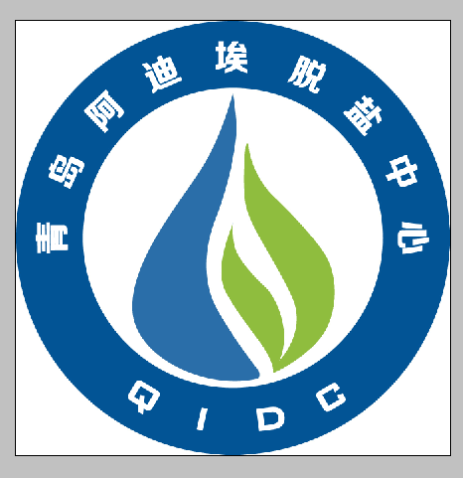

2016 Qingdao International Conference
on Desalination and Water Reuse

June 27—30，2016 Qingdao, China

- International Conference on Desalination and Water Reuse
- Conference on Industrial Water-saving and Pollution-control Technologies
- Summit on Development of China Water Purification Industry
- Conference on Water-saving &Wastewater Reuse Technology in Iron &Steel Industry
- Conference on Water Treatment Technology Innovation in Printing&Dyeing Industr
- China-EU Conference on Unconventional Water Resources Utilization
- Senior on municipal Sewage Treatment and Reuse
- International DWT Academic Seminar
- International Conference on Brine and Concentrated Water Comprehensive Utilization
- Conference on Sludge Treatment, Disposal and Reclamation

- Sponsored by the Chinese government, jointly supported by many global industry organizations;
- Over 1000 leaders, specialists and seniors of water treatment industry from more than 50 countries will gather together ;
- Over 100 famous experts will deliver presentations on desalination marketing and technology development strategy responding to global water crisis;
- Authoritative keynote speeches, sessions, workshops and seminars make face-to-face communication with industry users possible ;
- One of the largest, highest-level and the most influential and professional annual conference on desalination & water reuse in Asia-pacific region.
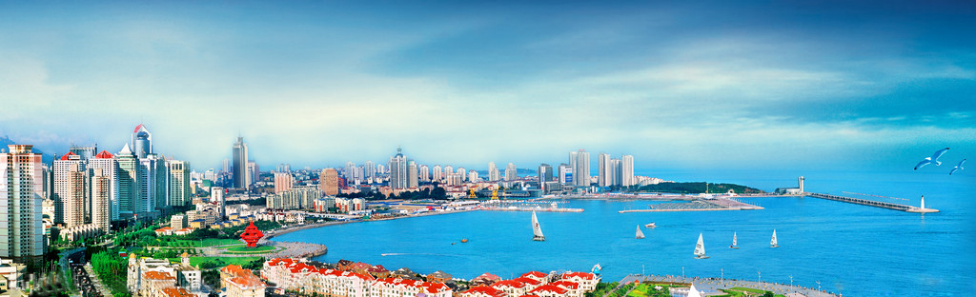


HOSTS
China Association for Science and Technology
Qingdao Municipal People's Government
SUPPORTERS
International Water Association
Desalination Branch of China Water Enterprises Confederation
Shandong Association for Science and Technology
Water-saving and Water Treatment Branch of China Industrial Energy
Conservation and Clean Production Association
ORGANIZERS
Qingdao International Desalination Center
Qingdao Association for Science and Technology
The Chinese Society for Metals
European Desalination Society (EDS)
Co- ORGANIZERS
Development and Strategy of China Water Purification Industry Confederation
Shandong Water Ecological Civilization Promotion Council
Shandong Salt Group Co., Ltd
Jiangsu water Purification Industry Association

ABOUT THE CONFERENCE
Qingdao International Conference on Desalination and Water Reuse is a high-end international academic and technical pageant, supported by International Water Association and related industrial organizations, co-organized by Desalination Branch of China Water Enterprises Confederation, European Desalination Society and other groups. The annual conference, which has been held for ten consecutive years, boasts great influence at home and abroad. The conference is aimed at creating a platform for exchanging ideas and information on the most advanced desalination & water reuse technology, engineering & industry, so as to spur the development of desalination industry in China and other countries around the world. Meanwhile leaders from water industry will be invited to make presentations on the development trend and the target and task of unconventional water resources industry, including national desalination and waste water reuse.
2016 Qingdao International Conference on Desalination and Water Reuse is scheduled on June 27—30, 2016, in Qingdao of China. The conference has been successfully held for ten years and has accumulated rich experience. With its abundant contents and a diversity of activities, the conference provides a platform for solving global water resources. Policymakers, experts and practitioners will gather together to share achievements and technologies, response to challenges and explore opportunities in desalination and water reuse industry. The annual pageant enjoys great reputation and influence and has become a renowned international conference in the Asian-pacific region. It’s a golden chance to make friends, communicate with top experts and enterprise representatives, and work together for promoting the development of desalination technology and industry.

WHO SHOULD ATTEND?
* Leaders who take charge of national and local water resources, water environment, water saving and water treatment;
* Experts, scholars, professors, and researchers in the field of global desalination and related areas;
* Member representatives of International Water Association, Desalination Branch of China Water Enterprises Confederation, European Desalination Society (EDS), Shandong Water Ecological Civilization Promotion Council and Environmental Chamber of Commerce and other professional associations or organizations;
* Engineering technicians from domestic and foreign water treatment companies, municipalities, entrepreneurs, investors, scientific research institutions, users and news agency.
ENTERPRISES OF PAST CONFERENCES
National Development and Reform Commission
Ministry of Science and Technology Ministry of Environmental Protection
Ministry of Water Resources
State Oceanic Administration People’s Republic of China
China Association for Science and Technology
The Institute of Seawater Desalination and Multipurpose Utilization, SOA (Tianjin)
Research and Development Center of Water Treatment Technology, Hangzhou
Gansu Academy of Membrane Science and Technology
Tsinghua University
Tianjin University
Ocean University of China
Dalian University of Technology
Tianjin Polytechnic University
Harbin Institute of Technology
Hohai University
Nanjing University of Technology
Zhejiang University
Xinxing Ductile Iron Pipes Co. , Ltd
China Metallurgical Group Corporation
China Huadian Engineering Group
Shanghai Electric (Group) Co
China First Heavy Industries
Harbin Electric (Group) Co
China Electronics Engineering Design Institute
Beijing Enterprises Water Group LimitedChina Power Engineering Consulting Group Company
Hydrochina Corporation
Beijing General Municipal Engineering Design & Research Institute
Shougang Institute of Technology
China Institute of WaterResources and Hydropower ResearchNingbo Institute of Material Technology & Engineering .Chinese Academy of Sciences
North West Electric Power Design Institute
GE Siemens Dow Veolia
Doosan Toray Degremont Nitto Denko
Abengoa BASF ITT KSB AG
LG Koch IDE AsahiKASEI
Hyflux Pentair Pall PUB Singapore
Cadagua ACS COBRA Aqualyng Black&veatch
ACWA Toshiba Hitachi LANXESS
Fesia Sidem EBARA Outokumpu
ERI Biwater Sulzer Pump Engineering
Calder AG Industeel Naclo SembCorp Utilities
Inge A.G. Toyobo BWA Prominent
Wabag BRACK Genesys Woongjin Chemical
Amiad Hach Butting Schlumberger Water
CH2M HILL Flowserve FCC Grundfos Pump
Kurita Danfoss Mitsubishi Sumitomo Corporation
Porex AkzoNobel ANDRLIZ Modern Water
GEMU ABB Litree Harbin ROPV
Bray MOTIMO Vontron Wave Cyber
Canpure Scinor Cobetter Nanfang Punp
Haier TCL 3M A.O.Smith
Unilever Ozner Angelgroup Tritech
SOLAREAST Iwowater RRS Originwater
MAIN TOPIC
Desalination: Innovation-driven & Green Development
MAIN CONTENT
Keynote speeches, plenary speeches, sessions, workshops, seminars, business negotiation, academic exchange, technology exhibition, government banquet, technical tour

THEMES
International Conference on Desalination and Water Reuse
- The status quo and development trend of desalination industry at home and abroad
- Innovation of membrane desalination technology
- Innovation of thermal desalination technology
- Desalination and environment issues
- Energy utilization and efficiency of seawater desalination and energy recovery technology
- Pre-treatment and post-treatment technology
- Process design, operation management and economic research of desalination system
- Anticorrosion control and material selection
- Application of complementary desalination products
- Innovation and development of water reuse technology
- Regeneration and comprehensive utilization of industrial and municipal wastewater
Conference on Industry Water-saving and pollution-controlling Technologies
Summit on Development of China Water Purification Industry
- The market of China water purification industry and its prospect
- The development trend of water purifier in view of drinking water quality and inspection in water purification industry
- Water-saving standards of water purifier and related policies
- Solutions to water safety in buildings, houses, campus and rural areas
- Quality guarantee of water purifier—materials and fittings choice
- The way to seize opportunities and respond to challenges for cross-border water purification companies
- Marketing and service of water purification Industry in the new period
Conference on Water-saving &Wastewater Reuse Technology in Iron & Steel Industry
- The status quo and development trend of water utilization in iron &steel industry
- The status quo and prospect of new water-saving and sewage treatment technology and equipment in iron &steel companies
- Water-saving technology of iron &steel companies and municipal wastewater treatment and regeneration technology
- Research techniques on water purification, water treatment and catalyst
- The status quo and prospect of desalination technology in the field of sewage treatment and utilization of iron &steel industry
- Treatment and reuse technology of tertiary treated wastewater and cooling circulating water

Innovation Conference on Water Treatment Technology in Printing &Dyeing Industry
- The existing situation and prospect of wastewater treating in printing & dyeing industry
- Technical discussion on industrial wastewater reuse methods and improvement of recycling rate in printing & dyeing enterprises
- Popularization and application of new technology, process, equipment and new drugs
- Cases analysis waste on water treatment in printing & dyeing industry
- Source and disposal solutions of sludge in printing & dyeing industry
- Sludge drying processing technology and equipment selection in printing & dyeing industry
Forum on Urban Construction and Development of Water Ecological Civilization
- Policy elucidation, beautiful construction of water ecological civilization in China
- Water ecological protection and development of national water park
- Conception and practice of urban construction of water ecological civilization
- Planning characteristics, issues and development trend of national water park
- Sustainable utilization of groundwater resources and water source protection
- Issues and experience on water ecological restoration
- Application of new technology, materials and equipment on water ecological restoration projects
Seminar on municipal Sewage Treatment and Reuse
International DWT Academic Seminar
- The latest progress in desalination technology and material research
- Cases of desalination development in advanced countries
- Development and application of new energy on desalination such as solar, wind and nuclear energy Membrane separation and osmosis technology
- Water-saving technologies and drinking water safety
- Water resources management and zero-liquid discharge technology
International Conference on Brine and Concentrated Water Comprehensive Utilization
- Aseptic technique development of desalination materials, Economic and technical analysis of combining desalination with chemical production
- Research on manufacturing salt and other comprehensive utilization of brine
- Technology of directly extracting potassium, bromine and other valuable chemical materials from brine, and deep processing
- Research on new technology and industry development strategy of comprehensive utilization of brine at home and abroad
- Energy saving technology on the production of salt and salty chemical products (include soda ash, caustic soda, PVC)
Conference on Sludge Treatment, Disposal and Reclamation
- The current situation and prospect on sludge treatment, disposal and reclamation in China
- Standards interpretation and policy discussion about urban sludge treatment and disposal as well as the 12th five-year plan for sludge industry
- Research and application of new-type sludge treatment and disposal technology and equipment
- Progress of urban sludge utilization technology
- Research, application and engineering examples of sludge reclamation technology, including sludge compost treatment, recycling sludge as building materials, and land utilization technology, etc.
- Technology research, engineering applications, design experience and management experience on commissioning and operation, on sludge reclamation at home and abroad

PAPER SELECTION AND PUBLICATION
- The length of the papers should be around 5,000 words, along with an abstract of 200-300 words. If you submit a paper in Chinese, you also should submit an abstract of 1,000 words in English.
- The title of the paper should reflect the nature and content of the paper and be no more than 12 words in length. All authors' names (maximum of 8) should be listed with the given name in full, all middle names as initials, followed by the family name in full.
3. Your digital figure files should not be separated from the text file. Text files (including figures) should be formatted to MS Word files, and remarked with full information of the speaker and/or organization. All margins 2.5 cm, Times New Roman, single spaced, all lines left-justified.
4. Arrangement: Title (14, bold), blank line, Authors a, b, c (12, regular), blank line, Addresses (10, regular), blank line, Abstract (10, regular), Key words (10, regular), Text (10, regular), blank line, References (10, regular). Please remember to include your fax number and office telephone number when submitting your paper.
After the conference, a selected number of full papers will be recommended for publication in the following journals. Followed is the paper format and style respective.
Desalination and Water Treatment (SCI journal) http://www.deswater.com/instructions.php
Water Science and Technology (SCI journal) https://www.editorialmanager.com/wst/
The recommended papers will go through a peer review process following the journal's own rules.
5. The deadline for submitting abstracts is March 31th and for full papers is May 31th, 2015. Please send your papers by email to yang_yan90@126.com.
CONFERENCE AGENDA
Date | Agenda
June 27, 2016 (Monday) | Registration
June 28, 20156(Tuesday) | Opening ceremony / Keynote Speeches / Sessions / Exhibition
June 29, 2016 (Wednesday) | Sessions / Plenary Speeches / Exhibition
June 30, 2016 (Thursday) | Technical Tour
VENUE
Hilton Hotel in Golden Beach, Qingdao, China
Add: No.1, East Jialing river road, the Economic & Technological Development Zone, Qingdao, China
Tel：+86-532-83150000

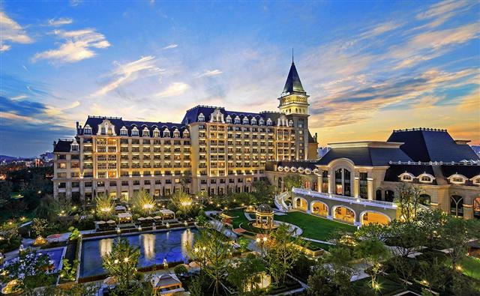

EXHIBITION OF TECHNOLOGY AND EUIPMENT
Exhibit Profile
Desalination and water treatment technology, products and equipment
Water treatment project and special necessary components for devices/auxiliary components special for devices
Membrane and membrane module and complete membrane equipment
Water-saving and wastewater reuse technology and equipment
Project technology and related/necessary/auxiliary management
Provider of professional media, information, consultancy and software
Sludge treatment equipment

Booth and Price Standards
Standard Booth (6 m²)
 | Foreign enterprises
Member | US $2,000
Non-member | US $2,200
The standard booths include: One table, two chairs, one fascia name board with both Chinese & English company name, two spotlights, one electric socket (220V), carpet.
REGISTRATION
 |  | Early registration  (Before April 1, 2016 ) | regular registration  on-site registration  (After April 1, 2016 )
Foreign delegates | Member | US$ 700 | US$ 800
Foreign delegates | Non-member | US$ 800 | US$ 900
Registration fee includes: Admittance to the sessions, meals, information kit and technical tour service.
ACCOMMODATION:
Representatives will be provided with arranged accommodation at their own expense.

EVENT SPONSORS
Choices of sponsoring are as follows:
Principal Event Sponsor Gold Sponsor Silver Sponsor
Banquet Sponsor Associate Sponsor Gift Sponsor
For those who want to become a sponsor of this event, please contact the organizing committee.

REGISTRATION DETAILS
1. Fill in the registration form and email or fax it to the organizing committee before 31st May, 2016.
2. Registration fee should be paid in advance or on-site.
3. After registration fee is paid, please submit the payment receipt to the organizing committee.

MODE OF PAYMENT
Intermediary Bank: JPMorgan Chase Bank New York
SWIFT BIC: CHASUS33
Beneficiary Bank: Bank of Communications Qingdao Branch
SWIFT BIC: COMMCNSHQDO
Customer's Name: Qingdao International Desalination Centre
Customer's A/c No: 372005513018170040169

CONTACTS
Desalination Branch of China Water Enterprises Confederation
Qingdao International Desalination Center
Qingdao Office
Contact: Gong Haichen Yuan Ping
Tel: 86-532-8667 9768
Fax: 86-532-8667 9769
E-mail: cdaghc@163.com lyndayuan@vip,163.com
Beijing Office
Contact: Yang Yan Bian Buhua
Tel: 86-10-58678266
Fax: 86-532-58678266
E-mail: yangyan@cda-ida.org.cn bianbuhua@ cda-ida.org.cn

2015 Qingdao International Conference on Desalination and Water Reuse
REGISTRATION AND ACCOMODATION FORM
June 2015

Registration
Family name First Name
Affiliation
Address
Country Tel.
Fax Email
- I plan to attend the conference
 |  | Early registration  (Before April 1, 2015 ) | regular registration  on-site registration  (After April 1, 2015 )
Foreign delegates | Member | □ US$ 700 | □ US$ 800
Foreign delegates | Non-member | US$ 800 | US$ 900

□ I plan to attend the technical tour
□ I intend to submit a paper entitled:
___________________________________________________________
□ I prefer oral presentation
□ I would like to book:
( ) One Standard Booth (6 m²)
- I would like to sponsor:
( )Principal Event Sponsor ( )Gold Sponsor ( )Silver Sponsor
( )Banquet Sponsor ( )Associate Sponsor ( )Gift Sponsor
- I intend to sponsor advertisements of the Proceedings:
( ) Back cover ( ) Inside back cover ( ) insert

Method of pay
Telegraphic Transfer (T/T) On-site Credit Card

Accomodation
Hotel | Room type |  | Breakfast | Internet | Tax / VAT | Service
Ocean spring metro park international hotel | Regular room | □Single bed | 1 included | Free wifi | Inclusive | Inclusive
Ocean spring metro park international hotel | Regular room | □Twin beds | 2 included | Free wifi | Inclusive | Inclusive
Ocean spring metro park international hotel | Deluxe Room | □Single bed | 1 included | Free wifi | Inclusive | Inclusive
Ocean spring metro park international hotel | Deluxe Room | □Twin beds | 2 included | Free wifi | Inclusive | Inclusive

Contact
Desalination Branch of China Water Enterprises Confederation
Beijing Office
Contact Person: Yang Yan, Bian Buhua
Tel: 86-10-6466 1601
Fax: 86-10-8468 3139
E-mail: yangyan@cda-ida.org.cn bianbuhua@vip.163.com

Qingdao International Desalination Center
Qingdao Office
Contact Person: Gong Haichen, Yuan Ping
Tel: 86-532-8667 9768
Fax: 86-532-8667 9769
E-mail: cdaghc@163.com lyndayuan@vip.163.com

